Investigation 10B: EXTRATROPICAL CYCLONE TRACK WEATHER
"Figure 1 shows a winter low-pressure system (extratropical cyclone) that at map time is intensifying over eastern Colorado. Over the subsequent two days, the storm system is forecast to track towards the Great Lakes region. Track A would have the cyclone center passing by Detroit to the southeast of the city and Track B would have the cyclone center passing by to the northwest of Detroit. In either case, the system would pass close enough to Detroit to have major consequences for the city’s weather. The potential positions of the cyclone center along each of the two tracks (Track A and Track B) at 12-hour intervals are indicated by heavy dots. As the cyclone tracks toward the Great Lakes, the system progresses through its life cycle. The cold and warm fronts gradually rotate about the cyclone center with the faster cold front closing in on the slower warm front.
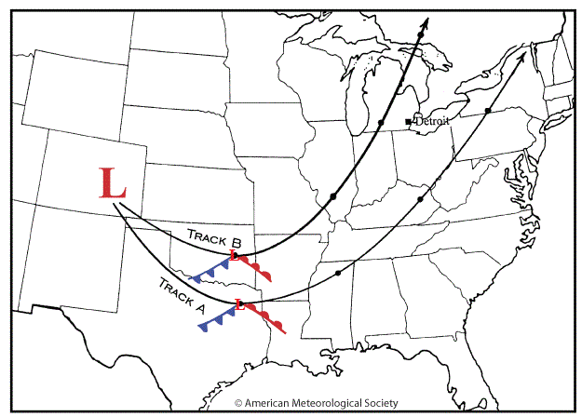

1. Using track A frontal positions shown in Texas as the starting point, pencil in the cyclone’s estimated cold and warm frontal positions at 12-hour intervals along its predicted path. Draw the fronts from the low-pressure center at each locations. For simplicity, draw the warm front in essentially the same position relative to the low pressure center and gradually rotate the cold front until it is oriented roughly north/south 24 hours after its Texas position. With Track A, residents of Detroit ______ experience the passage of fronts.
- do
- do not

2. Apply the hand-twist model of low pressure systems to the cyclone’s position at 12-hour intervals along Track A. Assume that before the storm’s arrival the wind at Detroit is blowing form the east. As the cyclone approaches the wind shifts form the east to the ______.
- southeast
- northeast

3. Considering the wind shifts and frontal positions at Detroit as the cyclone passes through the region along Track A, the city is on the relatively _______ side of the system.
- warm
- cold

4. Using the cyclone's Track B frontal positions in Oklahoma as a guide, pencil in the associated cold front and warm front at 12-hour intervals. Follow the same guidelines you employed in drawing Track A frontal positions. With Track B, residents of Detroit _______ experience the passage of fronts.
- do
- do not

5. Apply the hand-twist model of low pressure systems to each of the storm’s 12-hour positions along Track B. Assume that initially the wind at Detroit is blowing from the east. As the storm approaches the wind shifts from the east to the
- southeast
- northeast

6. Considering the wind shifts at Detroit as the cyclone’s center passes through Michigan along Track B, Detroit is positioned to experience weather related to the relatively ______ side of the system.
- warm
- cold

7. One extended period of substantial snowfall at Detroit is more likely if the cyclone takes Track ____.
- A
- B

8. Two periods of precipitation, more likely to be rain, separated by a short period of relatively warm fair weather at Detroit might occur if the cyclone takes Track ___
- A
- B

9. As the cyclone center approaches Detroit on either storm track, the air pressure at the city ____
- falls
- rises

10. As the cyclone center moves away from Detroit, the air pressure at the city ____
- falls
- rises

11. The next weather system to affect Detroit is likely a cold ______ approaching from central Canada.
- cyclone
- anticyclone

Applications

12. Figure 2 is the surface weather map for 12Z 25 Feb 2015. Dallas, in northeastern Texas, was north of the low-pressure center of the storm system, located in the western Gulf of Mexico at map time. The temperature at Dallas was ______ F and the dew point was 31.
- 27
- 31
- 33
- 35
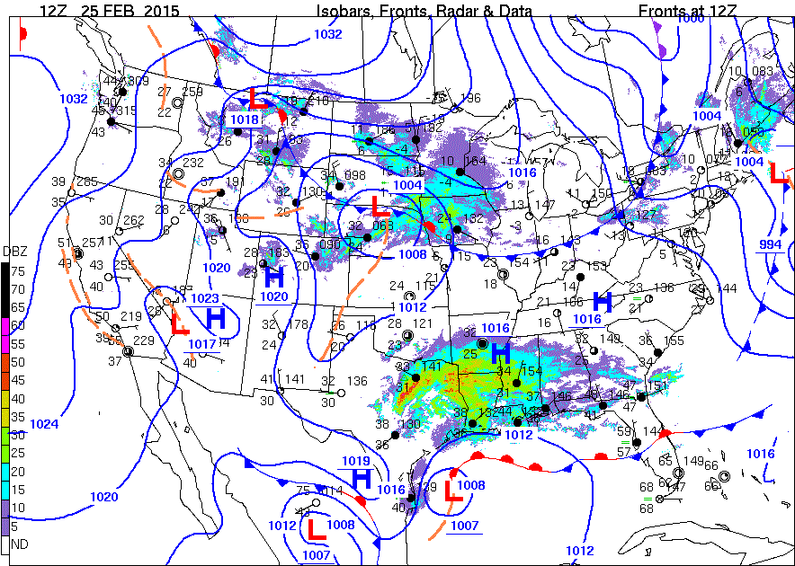

13. Dallas was located where radar echoes _____ detect precipitation occurring.
- did
- did not

14. "Dallas’ present weather condition at map time (shown faintly as a triangle with a dot in the middle ) in the station model indicated that ________ was occurring."
- rain
- drizzle
- ice pellets
- snow

15. "This type of precipitation ________ consistent with that occurring in winter storms."
- is
- is not

16. "Lake Charles, in southwest Louisiana, had a temperature of ________ °F and the dewpoint was 36 °F. Lake Charles was southeast of Dallas and closer to the Gulf and the off-shore warm front."
- 29
- 31
- 35
- 38

17. "Lake Charles’ present weather condition, shown faintly as two dots in the station model, indicated that ________ was occurring."
- rain
- drizzle
- ice pellets
- snow

18. "This type of precipitation ________ a frozen form."
- was
- was not

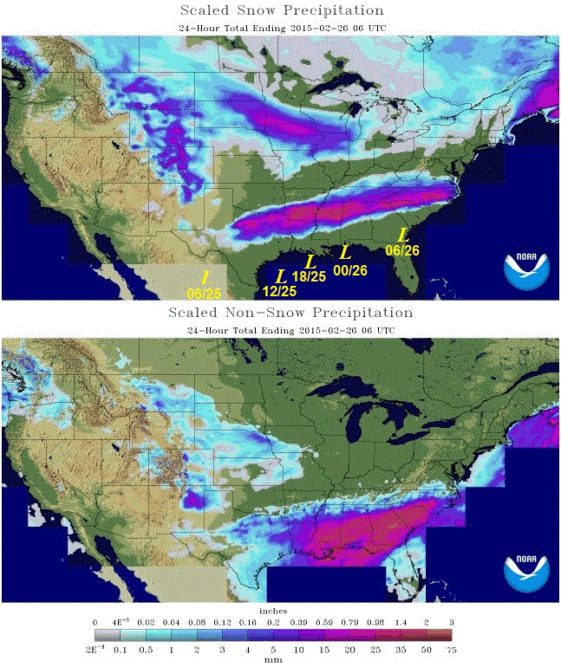

19. "The Figure 3 composite map showed the storm system’s low-pressure at 12Z 25 FEB 2015 by the yellow L located near the ________ coast, consistent with the Figure 2 position at that time."
- Texas
- Mississippi
- Florida
- Georgia

20. "Precipitation in the top and bottom panels of Figure 3 ________ generally cover the south-central and southeastern regions of the U.S. as a general eastward motion of an extratropical cyclone along the plotted track would be expected to produce."
- does
- does not

21. "The snow precipitation (upper panel) was located during this period to the ________ of the line you drew from Texas to North Carolina."
- north
- south

22. "The non-snow precipitation (lower panel) was located during this period, mostly to the ________ of the line you drew from Texas to North Carolina."
- north
- south

23. "The areas that experienced snow were located to the ________ of the storm track, your bold arrow."
- north
- south

24. "Placing yourself on the map on either of the storm track arrows and looking along the direction the storm moved, during the storm’s passage, the “cold” side would be to the _______ of the storm track."
- left
- right

25. "In the bottom, non-snow precipitation map, rain is found trending ________ the storm track."
- parallel to
- entirely south of

26. "Looking along the storm track arrow you placed on the non-snow precipitation map, during the storm’s passage, the “warm” side would be generally to the ________ of the track."
- left
- right

27. "The relative position of the cold-side, snow precipitation in this actual storm ________ generally consistent with the model presented in the introductory portion of Investigation 10B."
- was
- was not

